**Tutorial 2**

**Student Enrollment Case Study**

# Description

This tutorial will use the Student Case Study consisting of STUDENT2, SUBJECT2, OFFERING2 and ENROLLMENT2 tables.

The STUDENT2 table contains the personal details of students. The SUBJECT2 table keeps all the records of the available subjects. However, a single subject may have many offerings. This means that the same subject may be offered several times in a year as well as on different modes and campuses. Therefore, the OFFERING2 table stores the information of subjects being offered in particular semesters, etc. Basically, after a student selects a subject she/he is interested, she/he then needs to choose which semester or which campus she/he wants to take that subject. Once this is done, the details are stored in the ENROLLMENT2 table that will also store the Student ID and Offering ID as well as the score obtained by the student at the end of the semester.

Figure 1 shows an E/R diagram with four entities as well as their associated attributes. The sample data is also shown in Figure 2 below. Your first task is to create the four tables, and populate them with some records as shown Figure 2.

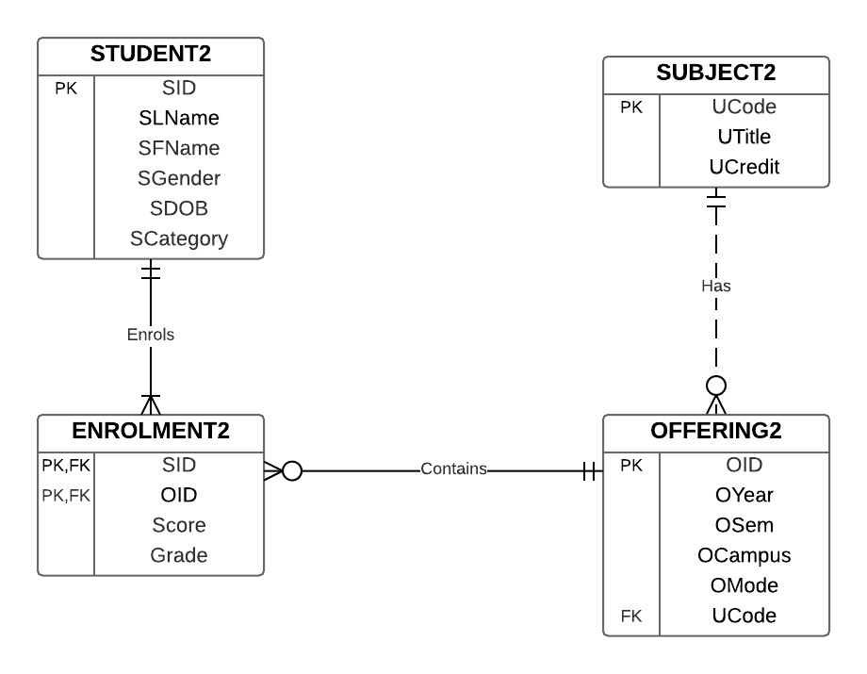

**Figure 1:** ER-Diagram for Student Case Study

|  |  |  |  |  |  |
| --- | --- | --- | --- | --- | --- |
| **Table Student2** | |  |  |  |  |
| **SID** | **Slname** | **Sfname** | **Sgender** | **Sdob** | **Scategory** |
| 10001 | Tan | Mirriam | F | 19-Jul-81 | 112 |
| 10002 | Murray | Juan | M | 10-Jun-83 | 211 |
| 10003 | Lay | Andy | M | 19-Feb-86 | 211 |
| 10004 | Wright | Allan | F | 29-Jan-83 | 211 |
| 10005 | Simon | Ally | F | 24-Aug-83 | 112 |
| 10006 | Smith | Ben | M | 9-Jul-87 | 211 |
| 10007 | Brown | Kate | F | 19-Oct-72 | 112 |
| 10008 | Miller | Larry | M | 22-Jul-73 | 211 |
| 10009 | Smith | Leonard | M | 26-May-85 | 211 |
| 10010 | Brown | Menson | M | 12-Jul-83 | 112 |

|  |  |  |
| --- | --- | --- |
| **Table Subject2** | |  |
| **Ucode** | **Utitle** | **Ucredit** |
| IT001 | Database | 5 |
| IT002 | Java | 5 |
| IT003 | SAP | 10 |
| IT004 | Network | 5 |
| IT005 | ASP.net | 5 |

|  |  |  |  |  |  |
| --- | --- | --- | --- | --- | --- |
| **Table Offering2** | |  |  |  |  |
| **OID** | **Oyear** | **Osem** | **Ocampus** | **Omode** | **Ucode** |
| 1 | 2009 | 1 | Main | D | IT001 |
| 2 | 2009 | 2 | City | E | IT001 |
| 3 | 2009 | 2 | DE | E | IT004 |
| 4 | 2009 | 2 | Main | D | IT002 |
| 5 | 2009 | 1 | City | E | IT003 |
| 6 | 2009 | 1 | Main | E | IT002 |
| 7 | 2010 | 1 | Main | D | IT001 |
| 8 | 2010 | 2 | City | E | IT001 |
| 9 | 2010 | 2 | DE | E | IT004 |
| 10 | 2010 | 2 | Main | D | IT002 |
| 11 | 2010 | 1 | City | E | IT003 |
| 12 | 2010 | 1 | Main | E | IT002 |

|  |  |  |  |
| --- | --- | --- | --- |
| **Table Enrollment2** | |  |  |
| **SID** | **OID** | **Score** | **Grade** |
| 10001 | 1 | 81 | HD |
| 10001 | 4 | 78 | D |
| 10002 | 2 | 64 | C |
| 10002 | 3 | 53 | P |
| 10003 | 2 | 32 | N |
| 10004 | 1 | 41 | N |
| 10005 | 5 | 63 | C |
| 10006 | 4 | 73 | D |
| 10006 | 1 | 74 | D |
| 10007 | 1 | 85 | HD |
| 10008 | 1 | 87 | HD |
| 10008 | 4 | 64 | C |
| 10009 | 1 | 75 | D |
| 10010 | 3 | 52 | P |
| 10005 | 6 | 65 | C |
| 10010 | 6 | 47 | N |

**Figure 2:** Tables and Records for the Student Enrollment Case Study

# Tasks

1. Create table SUBJECT2 and insert the above 5 records.

Create Table SUBJECT2 (

UCode Varchar2(10) NOT NULL,

UTitle Varchar2(20) NOT NULL,

UCredit Number(2),

PRIMARY KEY (Ucode)

);

Insert Into SUBJECT2 Values ('IT001', 'Database', 5);

Insert Into SUBJECT2 Values ('IT002', 'Java', 5);

Insert Into SUBJECT2 Values ('IT003', 'SAP', 10);

Insert Into SUBJECT2 Values ('IT004', 'Network', 5);

Insert Into SUBJECT2 Values ('IT005', 'ASP.NET', 5);

1. Table STUDENT2 has been created in the dtaniar account. Several records have been inserted to this table. You can now import table STUDENT2 to your account using the following SQL statement:

Create Table STUDENT2

As

Select *

From dtaniar.STUDENT2;

1. Describe the structure of table STUDENT2.

desc student2;

OR

describe student2;

Name Null? Type

----------------------------------------- -------- ---------------

SID NOT NULL VARCHAR2(10)

SLNAME NOT NULL VARCHAR2(20)

SFNAME NOT NULL VARCHAR2(20)

SGENDER CHAR(1)

SDOB DATE

SCATEGORY NUMBER(5)

1. Display all records from table STUDENT2.

select * from student2;

SID SLNAME SFNAME SGENDER SDOB SCATEGORY

---------- ---------- ---------- ------- ----------- ----------

10001 Tan Mirriam F 19/JUL/81 112

10002 Murray Juan M 10/JUN/83 211

10003 Lay Andy M 19/JUL/86 211

10004 Wright Allan F 29/JAN/83 211

10005 Simon Ally F 24/AUG/83 112

10006 Smith Ben M 09/JUL/87 211

10007 Brown Kate F 19/OCT/72 112

7 rows selected.

1. Insert the missing records to table STUDENT2.

Insert Into STUDENT2 Values ('10008', 'Miller', 'Larry', 'M', To_date('22-07-1973', 'DD-MM-YYYY'), 211);

Insert Into STUDENT2 Values ('10009', 'Smith', 'Leonard', 'M', To_date('26-05-1985', 'DD-MM-YYYY'), 211);

Insert Into STUDENT2 Values ('10010', 'Brown', 'Menson', 'M', To_date('12-07-1983', 'DD-MM-YYYY'), 112);

1. Import Tables OFFERING2 and ENROLLMENT2 from dtaniar account. The method is similar to question (*b*) above.

CREATE TABLE Offering2

AS

SELECT *

FROM dtaniar.Offering2;

CREATE TABLE Enrollment2

AS

SELECT *

FROM dtaniar.Enrollment2;

1. Using SQL to answer the questions:
2. How many students enrolled in the Database unit offered in Main campus?

select count(*) as Number_of_student

from Offering2 o, Enrollment2 e, Subject2 s

where e.OID = o.OID

and s.Ucode = o.Ucode

and o.Ocampus = 'Main'

and s.Utitle = 'Database';

OR

select count(st.sid) as Number_of_student

from Student2 st, Offering2 o, Enrollment2 e, Subject2 s

where st.SID = e.SID

and e.OID = o.OID

and s.Ucode = o.Ucode

and o.Ocampus = 'Main'

and s.Utitle = 'Database';

ANSWER:

NUMBER_OF_STUDENT

-----------------

6

1. What is the total score of students taking the Database unit in Main campus?

select SUM(e.score) as Total_score

from Offering2 o, Enrollment2 e, Subject2 s

where e.OID = o.OID

and s.Ucode = o.Ucode

and o.Ocampus = 'Main'

and s.Utitle = 'Database';

ANSWER:

TOTAL_SCORE

-----------

443

1. How many students enrolled in the Java unit offered in Semester 2, 2009?

select count(*) as Number_of_student

from Offering2 o, Enrollment2 e, Subject2 s

where e.OID = o.OID

and s.Ucode = o.Ucode

and s.Utitle = 'Java'

and o.Osem = 2

and o.Oyear = 2009;

OR

select count(st.sid) as Number_of_student

from Student2 st, Offering2 o, Enrollment2 e, Subject2 s

where st.SID = e.SID

and e.OID = o.OID

and s.Ucode = o.Ucode

and s.Utitle = 'Java'

and o.Osem = 2

and o.Oyear = 2009;

ANSWER:

NUMBER_OF_STUDENT

-----------------

3

1. What is the total score of students taking the Java unit in Semester 2, 2009?

select SUM(e.score) as Total_score

from Offering2 o, Enrollment2 e, Subject2 s

where e.OID = o.OID

and s.Ucode = o.Ucode

and s.Utitle = 'Java'

and o.Osem = 2

and o.Oyear = 2009;

ANSWER:

TOTAL_SCORE

-----------

215

1. How many students received HD in the SAP unit offered in Semester 1, 2009?

select count(*) as Number_of_student

from Offering2 o, Enrollment2 e, Subject2 s

where e.OID = o.OID

and s.Ucode = o.Ucode

and e.Grade = 'HD'

and s.Utitle = 'SAP'

and o.Osem = 1

and o.Oyear = 2009;

OR

select count(st.sid) as Number_of_student

from Student2 st, Offering2 o, Enrollment2 e, Subject2 s

where st.SID = e.SID

and e.OID = o.OID

and s.Ucode = o.Ucode

and e.Grade = 'HD'

and s.Utitle = 'SAP'

and o.Osem = 1

and o.Oyear = 2009;

ANSWER:

NUMBER_OF_STUDENT

-----------------

0

**Implementing the star schema:**

1. Draw a star schema based on the above case study? First identify the dimensions (and their attributes), and the fact measurements for the fact table?



1. Use the SQL command to create and populate the dimension tables.

--Campus dimension

Create table campus_dim as

SELECT distinct Ocampus

FROM Offering2;

--Semester_year dimension

Create table sem_year_dim as

SELECT distinct Oyear||Osem as sem_id, Oyear, Osem

FROM Offering2;

--Subject Dimension

Create table subject_dim as

SELECT *

FROM subject2;

--Grade Dimension

Create table grade_dim as

SELECT distinct Grade

FROM Enrollment2;

1. Use the SQL command to create the fact table.

create table student_enrollment_fact as

SELECT o.Ocampus, o.Oyear||o.Osem as sem_id, s.Ucode, e.Grade, count(st.sid) as num_of_student, sum(e.score) as Total_score

FROM subject2 s, enrollment2 e, offering2 o, student2 st

WHERE e.OID = o.OID

and s.Ucode = o.Ucode

and st.SID = e.SID

GROUP BY o.Ocampus, o.Oyear||o.Osem, s.Ucode, e.Grade;

Alternatively, we can avoid using table student2:

create table student_enrollment_fact as

SELECT o.Ocampus, o.Oyear||o.Osem as sem_id, s.Ucode, e.Grade,

count(e.sid) as num_of_student, sum(e.score) as Total_score

FROM subject2 s, enrollment2 e, offering2 o

WHERE e.OID = o.OID

and s.Ucode = o.Ucode

GROUP BY o.Ocampus, o.Oyear||o.Osem, s.Ucode, e.Grade;

Further, we can also avoid using table subject2:

create table student_enrollment_fact as

SELECT o.Ocampus, o.Oyear||o.Osem as sem_id, o.Ucode, e.Grade,

count(e.sid) as num_of_student, sum(e.score) as Total_score

FROM enrollment2 e, offering2 o

WHERE e.OID = o.OID

GROUP BY o.Ocampus, o.Oyear||o.Osem, o.Ucode, e.Grade;

1. Use the star schema that you have created, display the average score of each unit offered in 2009.

SELECT s.utitle, sum(f.Total_score)/sum(f.num_of_student) as Avg_score

from student_enrollment_fact f, subject_dim s, sem_year_dim y

WHERE f.ucode = s.ucode

AND f.sem_id = y.sem_id

AND y.oyear = 2009

Group by s.utitle;

UTITLE AVG_SCORE

-------------------- ----------

SAP 63

Java 65.4

Network 52.5

Database 67.375

1. Use the star schema that you have created, display the average score of each unit offered in main campus.

SELECT s.utitle, sum(f.Total_score)/sum(f.num_of_student) as Avg_score

from student_enrollment_fact f, subject_dim s, campus_dim c

WHERE f.ucode = s.ucode

AND f.ocampus = c.ocampus

AND c.ocampus = 'Main'

Group by s.utitle;

UTITLE AVG_SCORE

-------------------- ----------

Java 65.4

Database 73.8333333

1. Use the star schema that you have created, display the average score of Database unit with the grade N.

SELECT s.utitle, sum(f.Total_score)/sum(f.num_of_student) as Avg_score

from student_enrollment_fact f, subject_dim s, grade_dim g

WHERE f.ucode = s.ucode

AND f.grade = g.grade

AND s.utitle = 'Database'

AND g.grade = 'N'

Group by s.utitle;

UTITLE AVG_SCORE

-------------------- ----------

Database 36.5

**THE END**